Hemodynamics of Coronary Artery Aneurysms in Kawasaki Disease — An Idealized Aneurysm Model

Alexander Lu

May 13, 2019

HEMODYNAMICS OF CORONARY ARTERY ANEURYSMS IN KAWASAKI DISEASE — AN IDEALIZED ANEURYSM MODEL

An Honors Thesis Submitted to

Biomedical Computation

in partial fulfillment of the Honors Program

STANFORD UNIVERSITY

by

ALEXANDER LU

May 13, 2019

Contents

1 Abstract 1

2 Introduction 2

3 Methodology 4

**3.1 Idealized Aneurysm Models 4**

**3.2 Computational Hemodynamics 5**

**3.3 Residence Time Calculation 6**

**3.4 Post-Simulation Analysis 7**

4 Results 8

5 Discussion 8

6 Acknowledgements 9

7 References 10

List of Tables

List of Figures

# Abstract

# Introduction

Kawasaki Disease (KD), a vasculitis of unknown etiology typically occurring in infants and young children, is the leading cause of acquired heart disease in childhood in developed countries. Approximately 20-25% of patients may eventually develop coronary artery aneurysms (CAAs) if not treated within ten days of disease onset. Unlike cerebral or abdominal aorta aneurysms, which pose a risk of rupture, CAAs are threatening in their potential for inducing thrombus formation, resulting in myocardial infarction and sudden death.

CAAs resulting from KD can adopt a wide range of shapes and sizes across a range of locations within the coronary tree. Size classification often relies on maximum aneurysm diameter, with potential normalization based on body surface area (Z-score) to label aneurysms as uninvolved, small, medium, or giant. CAAs may also be roughly classified by shape into groups such as saccular, fusiform, and string-of-pearls. A final classification is based on the number of major coronary vessels which bear aneurysms. Coupled with interpatient variability in hemodynamic factors such as blood pressure and cardiac output, wide variability in aneurysm size, shape, and position amplifies difficulty in isolating the effects of geometric parameters. Indeed, complex geometry, as well as aneurysm shape, number, and location, may all contribute to abnormal hemodynamics and correlate with patient outcome.

Presently, the American Heart Association offers guidelines for stratification of patient thrombotic risk that rely on aneurysm size alone as the criterion for initiating systemic anticoagulation; however studies suggest risk may also depend on hemodynamic parameters such as time-averaged wall shear stress (TAWSS), residence time (RT), and oscillatory shear index (OSI), which are not available through image data alone. Patient-specific hemodynamic simulations can non-invasively supply informative hemodynamic parameters for better thrombotic risk assessment; however, existing studies have been limited in patient cohort size and struggle to quantify effects of aneurysm shape on local hemodynamics.

With such limitations in mind, existing patient-specific models can be augmented by introducing artificial aneurysms of specified length and diameter, to achieve a systematic evaluation of relationship between CAA shape, size, and position on local hemodynamics. Ultimately, elucidating the relationship between hemodynamics and aneurysmal shape characteristics may underlie more powerful risk stratification methods to support clinical decision-making regarding initiation of anticoagulation therapy.

# Methodology

## Idealized Aneurysm Models

A pipeline for generation of three-dimensional idealized aneurysm models has been constructed with dependencies on the Visualization ToolKit Package (VTK). The pipeline workflow consists of the following three steps.

***(1) Baseline Model***An existing patient-specific model of the aorta and coronary vasculature was constructed from coronary CT image data in Simvascular, an open source software which provides a full pipeline for patient-specific cardiovascular simulation. This baseline model is constructed through manual identification of preliminary vessel centerlines, 2D segmentation of vessel contours, and lofting contours to form vessel walls. The union of all vessel walls is taken as the three-dimensional model, represented as a triangular mesh in 3D space.

***(2) Surface Parameterization*** Vessel centerlines are re-extracted from the three-dimensional model in Simvascular, then upsampled from cubic spline interpolation to achieve sufficient spatial resolution in the centerline’s discretization. Points from the 3D model’s wall are expressed in terms of distance along the centerline, $s(t)$, by mapping each wall point to the resampled centerline point that minimizes $L_{2}$ distance. The Frenet-Serret reference frame is then constructed from the centerline to label each wall point with its angle $ϕ\left(t\right)∈[-π, π]$ with respect to the centerline’s unit normal $n(t)$. This combination of position and angle with respect to the centerline enables efficient generation of artificial aneurysms.

***(3) Aneurysm Generation*** Existing AHA aneurysm classification for small, medium, and giant CAAs serves as a guide to proceed from body surface area-normalized Z-score to an estimated maximal diameter for a given coronary vessel. The Z-score formulation presented in Dallaire and Dahdah et al. 2011,

$$Z= \frac{\text{C}{\text{A}}_{\text{obs}}-[a+\left(b ×\sqrt{\text{BSA}} \right)]}{a_{\text{SE}}+(b_{\text{SE}}×\sqrt{\text{BSA}} )}$$

with coefficients $a, b, a_{SE}, b_{SE}$ estimated separately for each vessel. Using aneurysmal shape index (ASI), defined as the ratio of aneurysmal length to maximal lumen diameter,

$$\begin{aligned}\text{ASI= }\frac{\text{aneurysm length}}{\text{aneurysm diameter}}\text{\#}\#(1)\end{aligned}$$

we obtain a range of lengths and diameters to guide aneurysm generation.

**Figure __:** A baseline model serves as the basis for producing idealized aneurysms with varying positions, lengths, diameters. **a.** Baseline model of aorta, coronary vasculature with RCA, LAD highlighted. **b.** Aneurysms with shape index of 2 generated at 3 positions along the RCA, and at 1 position in the LAD. **c, d.** Aneurysms with shape index 4, 6 respectively generated at 1 position each along RCA, LAD.

**a**

**b**

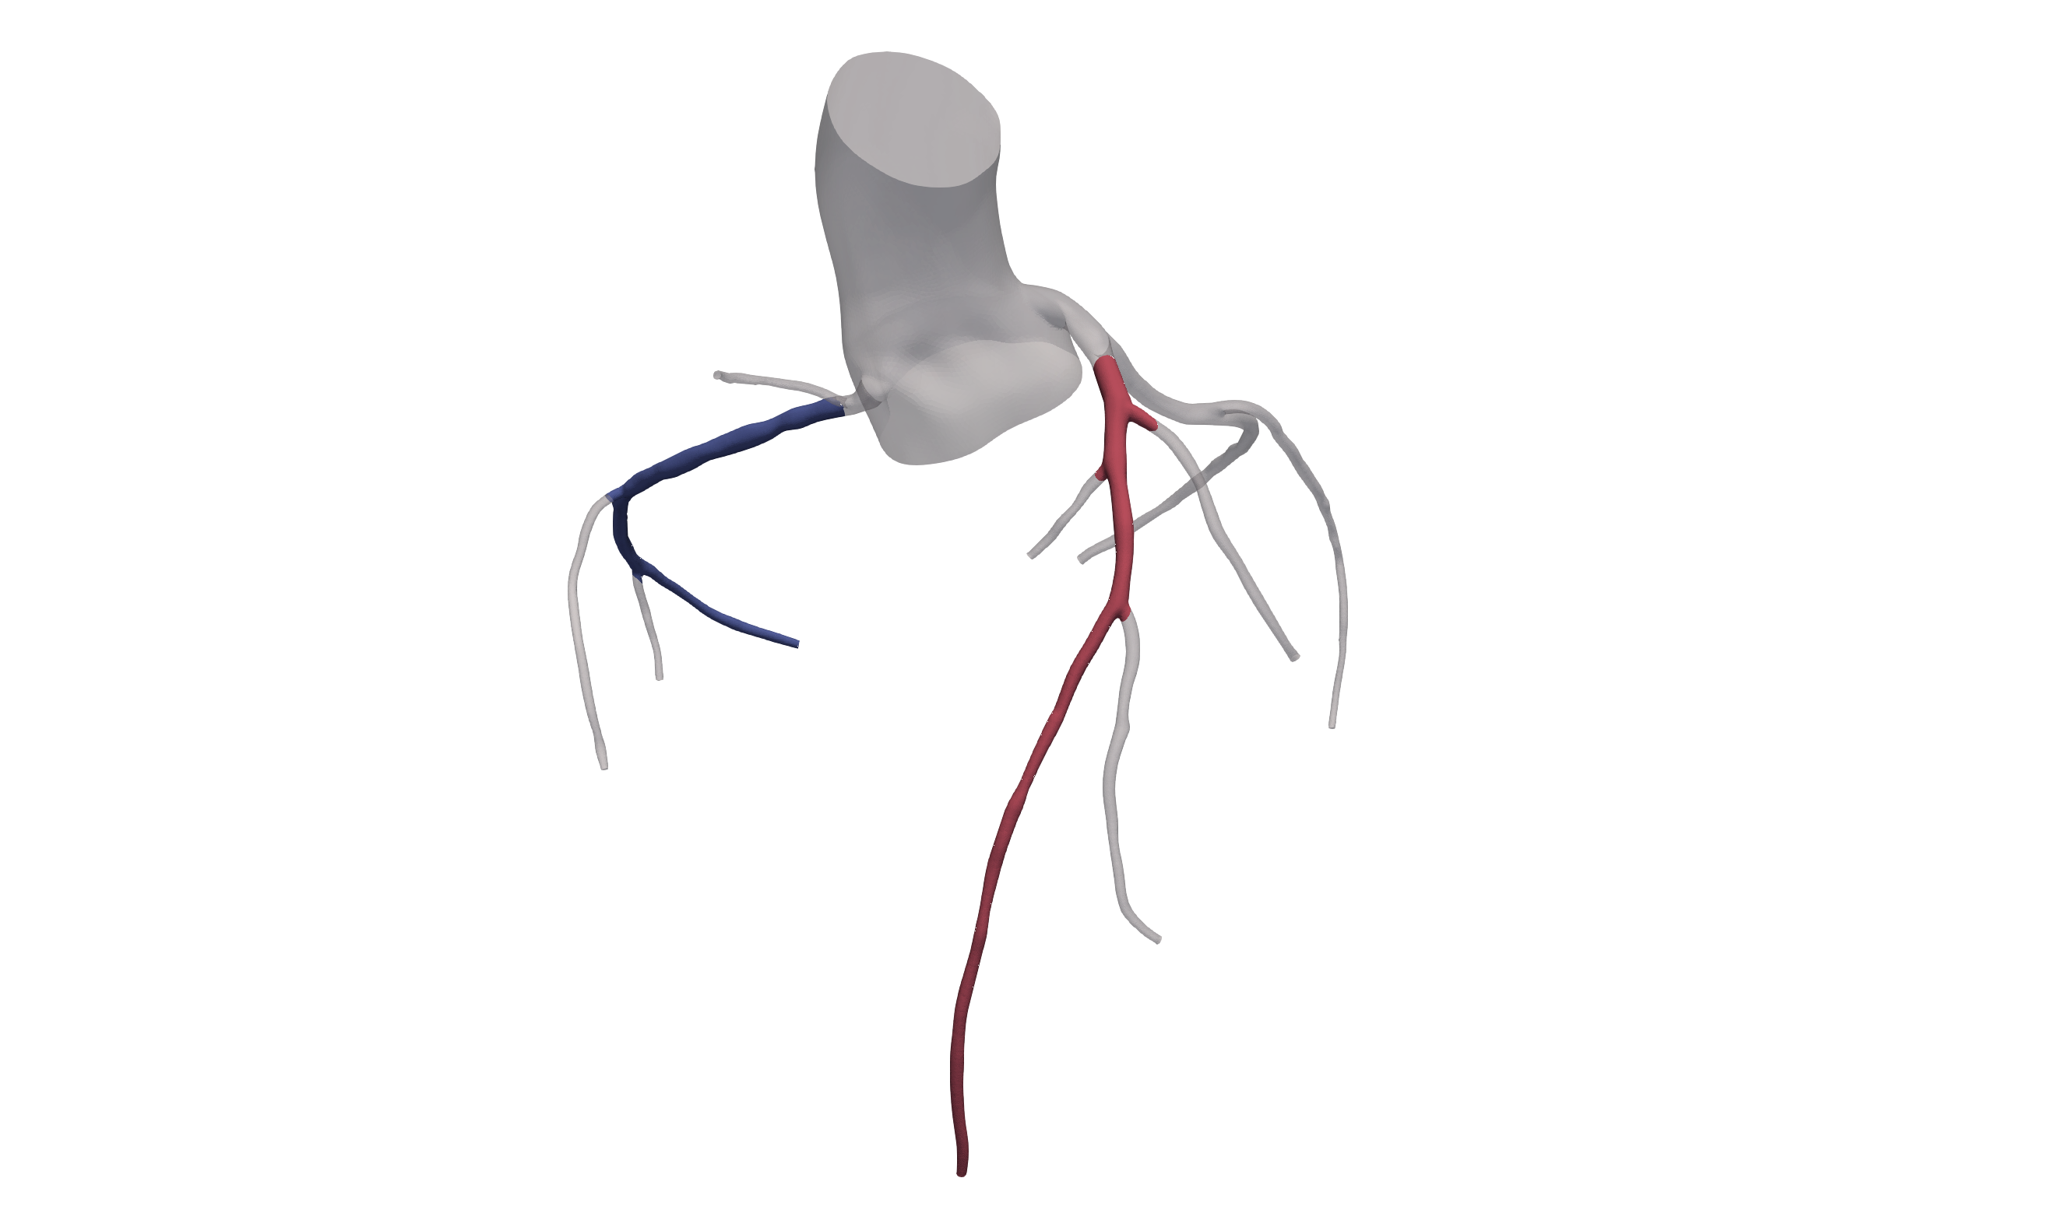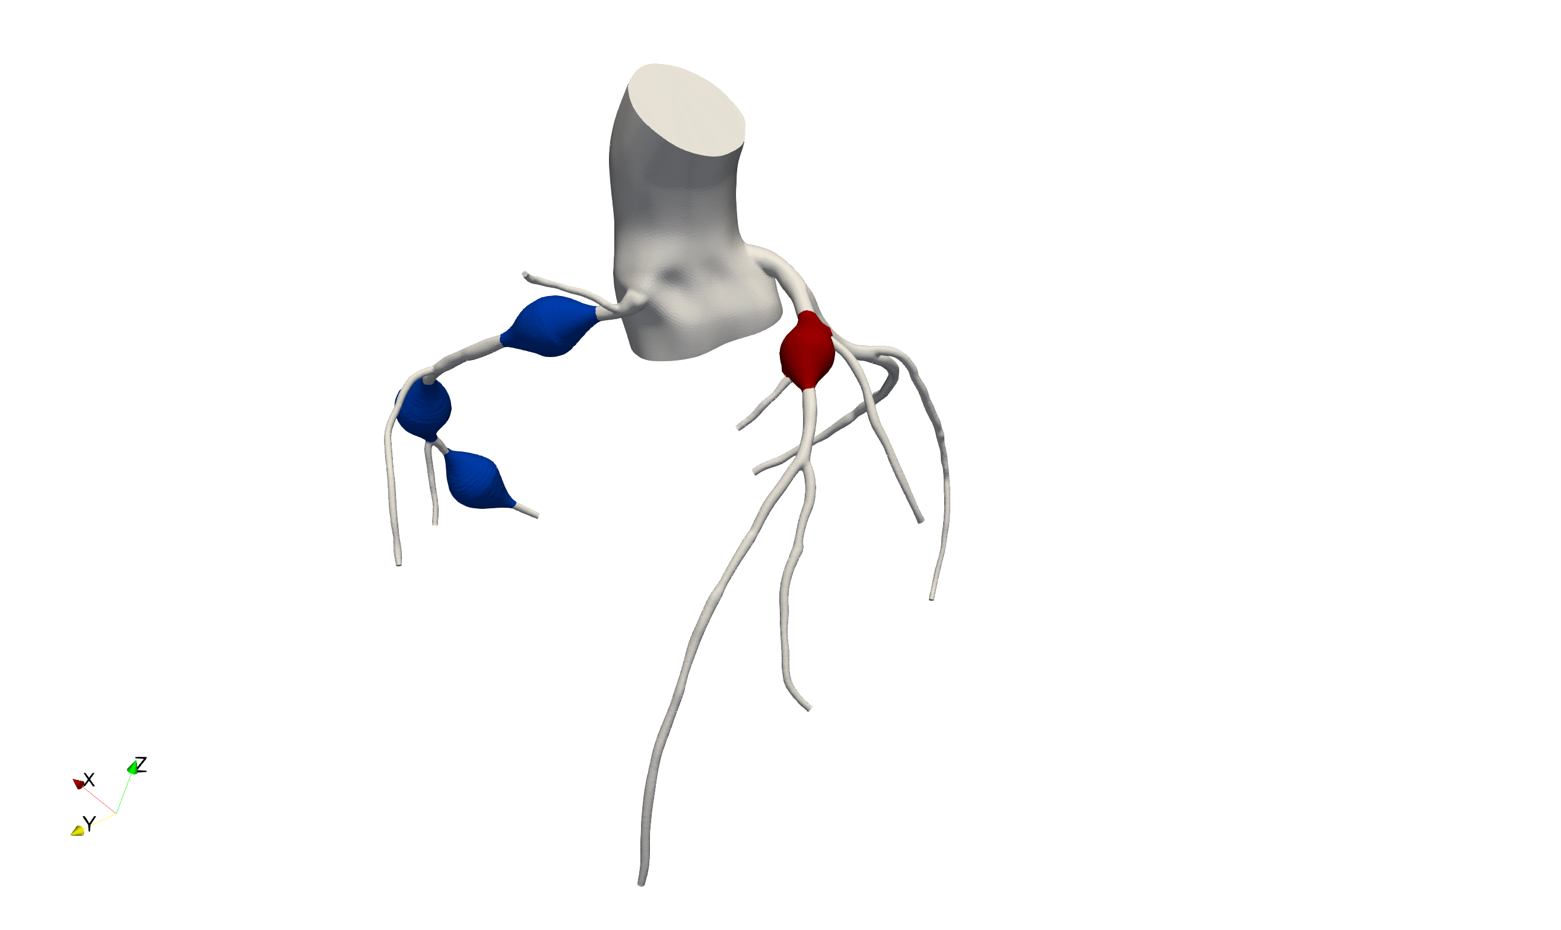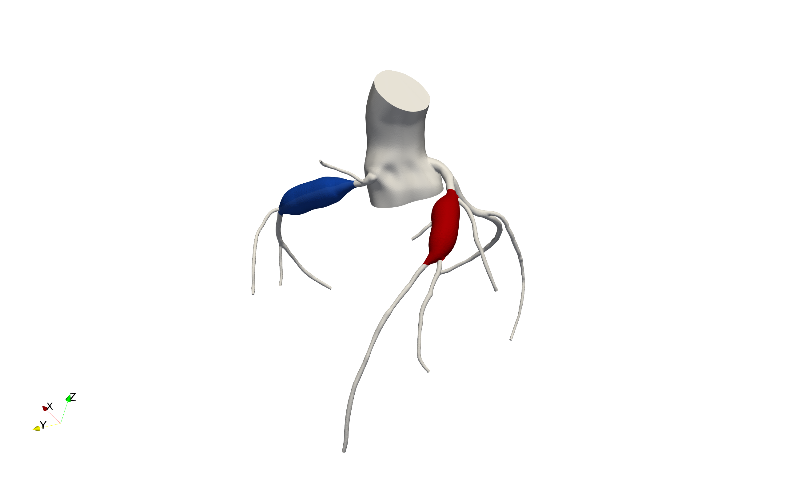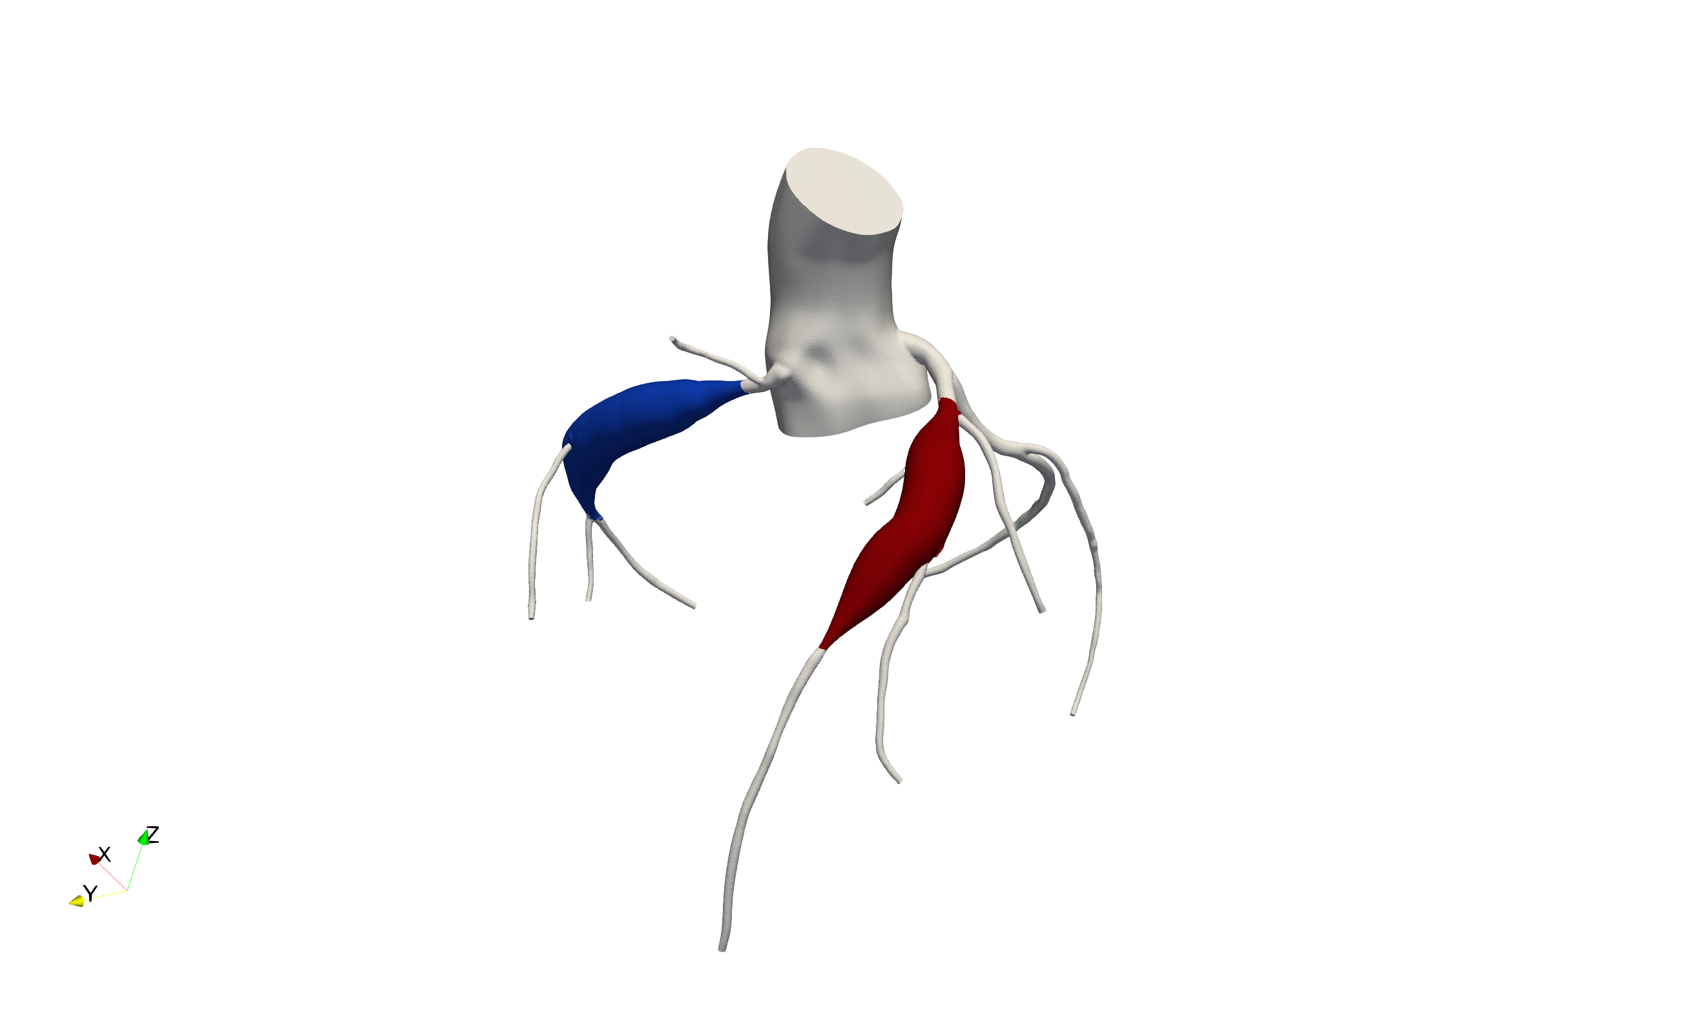

**c**

**d**

For a given target length and maximum diameter, we can use the position and angle parameterizations determined in step *(2)* to deform the vessel wall. Deformation magnitude is given through second-order smooth interpolation of diameter as a function of centerline position, producing radial symmetry. In the case of vessel branching from the desired aneurysm region, all points of the bifurcating vessel and its branches are shifted and rotated according to the average deformation at the bifurcation. Empirically, this method has worked best to control bifurcation angle between baseline and artificial aneurysms of varying shape and maximal diameter. This process was applied for multiple positions, sizes, and diameters, exemplified in **Figure ???.**

## Computational Hemodynamics

Generated aneurysm models are further processed in Simvascular using Tetgen, an open source package for mesh generation included in Simvascular. Tetrahedral finite element meshes with boundary layer meshing are generated for each model. The Simvascular solver then computes a numerical solution to the time-dependent Navier-Stokes equations governing blood flow. Blood is modeled as an incompressible Newtonian fluid (density=1.06 g/cc, dynamic viscosity=0.04 dynes/cm2) and walls are assumed to be rigid in all cases.

***Simulation Boundary Conditions*** Systolic myocardial contraction increases intra-myocardial pressure, transiently increasing distal coronary resistance substantially and causing coronary flow to be out of phase with systemic flow. Specialized boundary conditions coupling intra-myocardial pressure to coronary flow are required to replicate this complex physiology in the numerical model. We achieve this by modeling the heart and distal vasculature with a closed-loop, Lumped Parameter Network (LPN), which imposes boundary conditions with tunable parameters to produce physiologically accurate cardiac output, heart rate, blood pressure, and flow distributions. For all idealized models described in this work, LPN parameters are fixed to better isolate the effects of aneurysmal geometry on hemodynamics. **Figure ????** shows the full pipeline, proceeding from baseline model to artificial aneurysms and simulation results over isolated aneurysm regions.

## Residence Time Calculation

Although pathways underlying platelet activation and thrombosis remain poorly understood, flow recirculation and stagnation have been hypothesized to contribute to thrombosis. To better understand aneurysm hemodynamics, we can employ Residence Time (RT), which has been shown to be an effective measure of quantifying recirculating flow that traps fluid for an extended duration. RT is computed as described in Esmaily-Moghadam et al. 2013, by first solving the advection-diffusion equation:

$$\frac{∂τ}{∂t}+u⋅∇τ-∇⋅κ∇τ-H=0$$

where $τ$ is a measure of time only tracked for elements inside the region of interest, $Ω_{τ}$; $u$ is the velocity field from solving the Navier-Stokes equation; $κ$ is the diffusivity; $H$ is the particle source term. RT is then computed as:

$$RT= \frac{1}{T}\int_{\left(n-1\right)T}^{nT}{\frac{1}{V_{Ω_{τ}}}}\int_{Ω_{τ}}{τ\left(x, t\right)dΩdt}$$

$$V_{Ω_{τ}}=\int_{Ω_{τ}}{dΩ}$$

Intuitively, RT is computed by injecting massless particles into the velocity field output by hemodynamic simulations and inspecting the spatially and temporally averaged time spent in the region of interest. In our cases, $Ω_{τ}$ contains all elements within the aneurysmal volume and $κ$ is set to 0.

## Post-Simulation Analysis

Understanding local aneurysm hemodynamics can be simplified by isolating the aneurysmal region of interest. Aggregate measures of certain hemodynamic quantities, such as WSS, can then be computed either over the isolated aneurysm surface, or over the aneurysm volume. Given the surface discretization as a triangular mesh, the average of a quantity of interest is computed by weighting nodal values by the area of each triangular face. The post-simulation analysis pipeline — including thresholding operations, variable integration, and simulation data visualization — was developed using custom scripts interfacing with Paraview (<https://www.paraview.org/>), an open-source data-analysis and visualization application.

## Comparison Against Patient-Specific Cases

Idealized aneurysm models were compared against simulation data produced using patient-specific models of coronary aneurysms in Kawasaki Disease.

# Results

Idealized aneurysms of 3 representative shape index values (ASI = 2, 4, 6) were generated for 5 diameters (z-score = 6, 8, 10, 12, 14) at three positions along the right coronary artery (RCA) and one position in the left anterior descending (LAD) for a total of 40 cases. Hemodynamic simulation results were isolated over aneurysmal regions to identify the effects of shape, size, and position on local hemodynamic conditions.

**Figure __:** A representative collection of artificial aneurysms generated at 3 ASI values (2, 4, 6) with 5 Z-scores (6, 8, 10, 12, 14) while fixing the aneurysm inlet position at the proximal RCA. The Time-Averaged Wall Shear Stress is displayed over the surface, demonstrating consistent variation of hemodynamic behavior with respect to Z-score.



TAWSS (dynes/cm^2)

0.0

10.0

**a**

Increasing Z-score

Increasing ASI

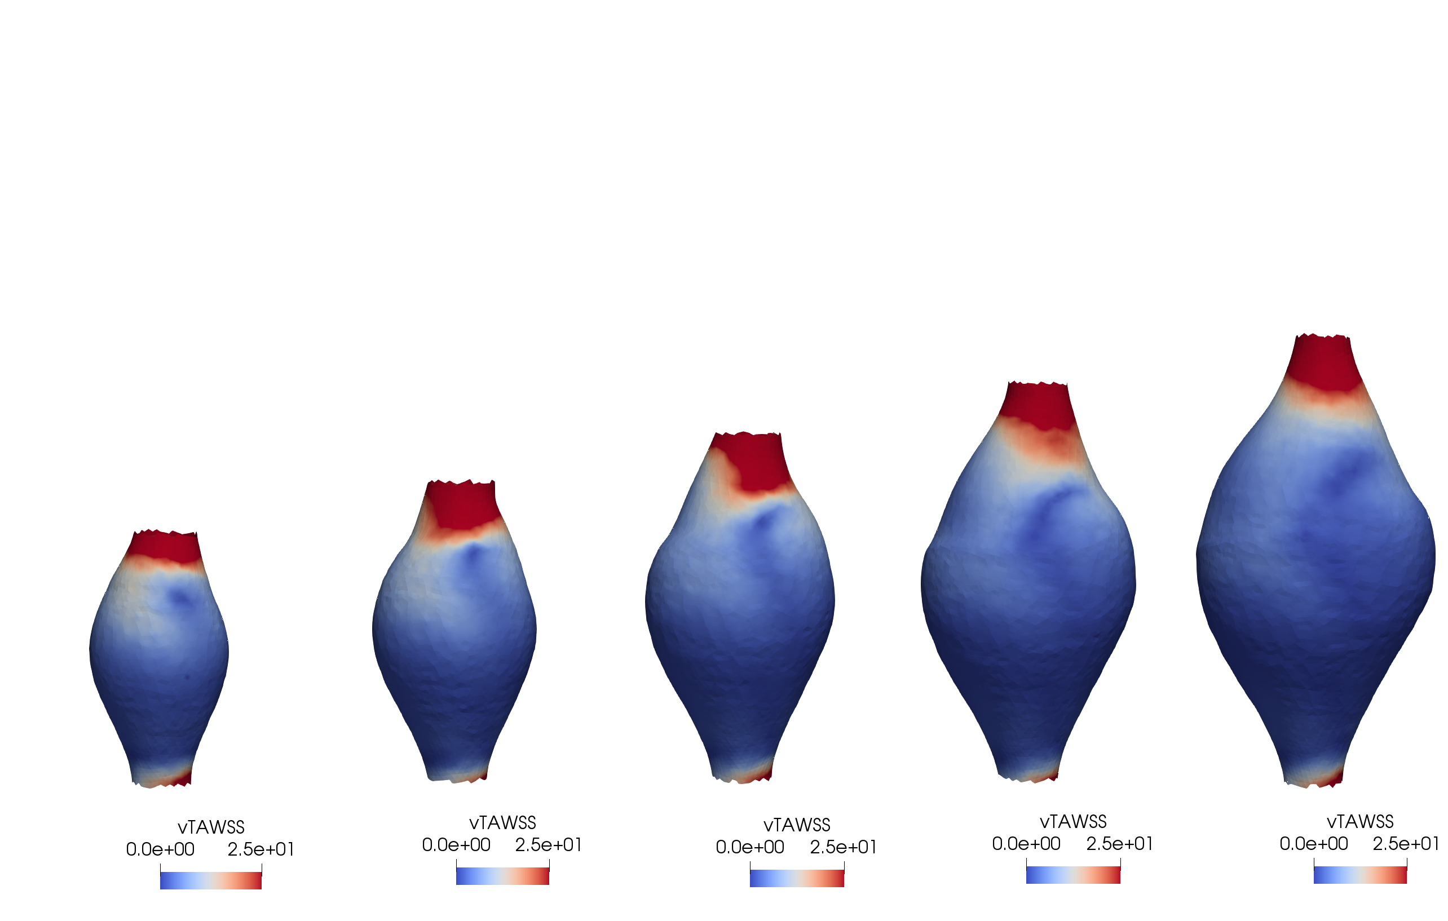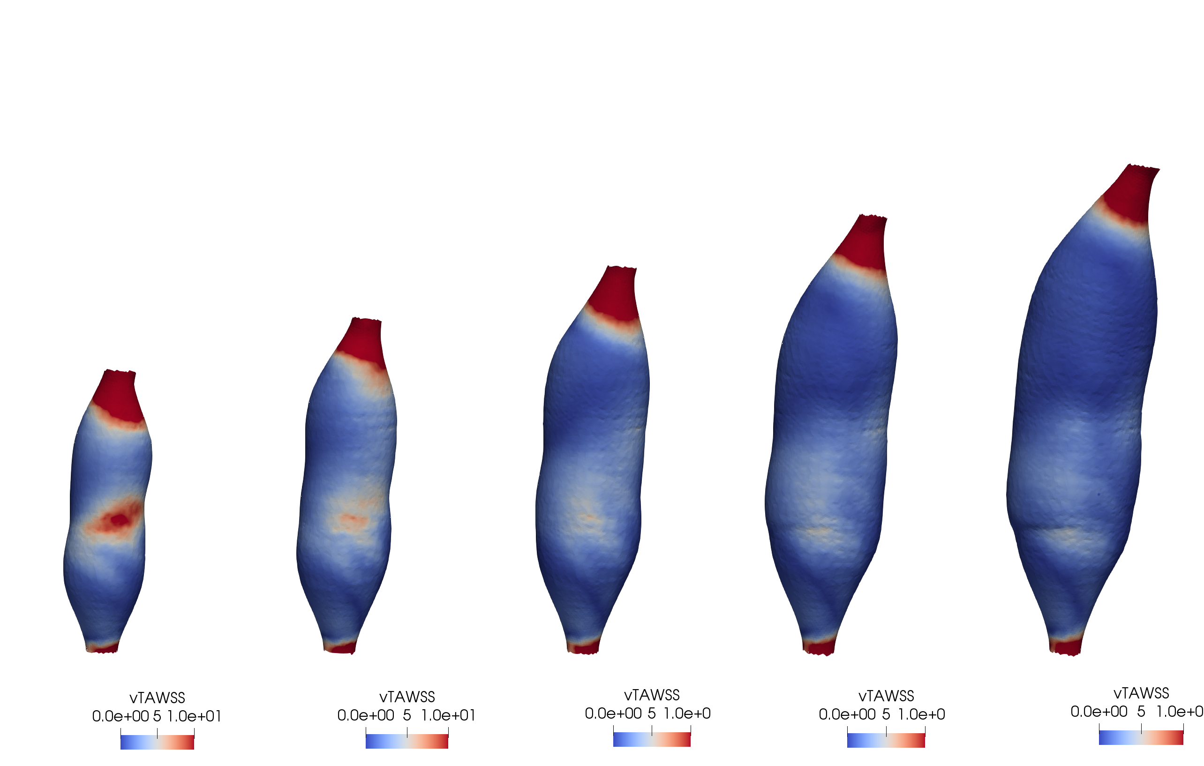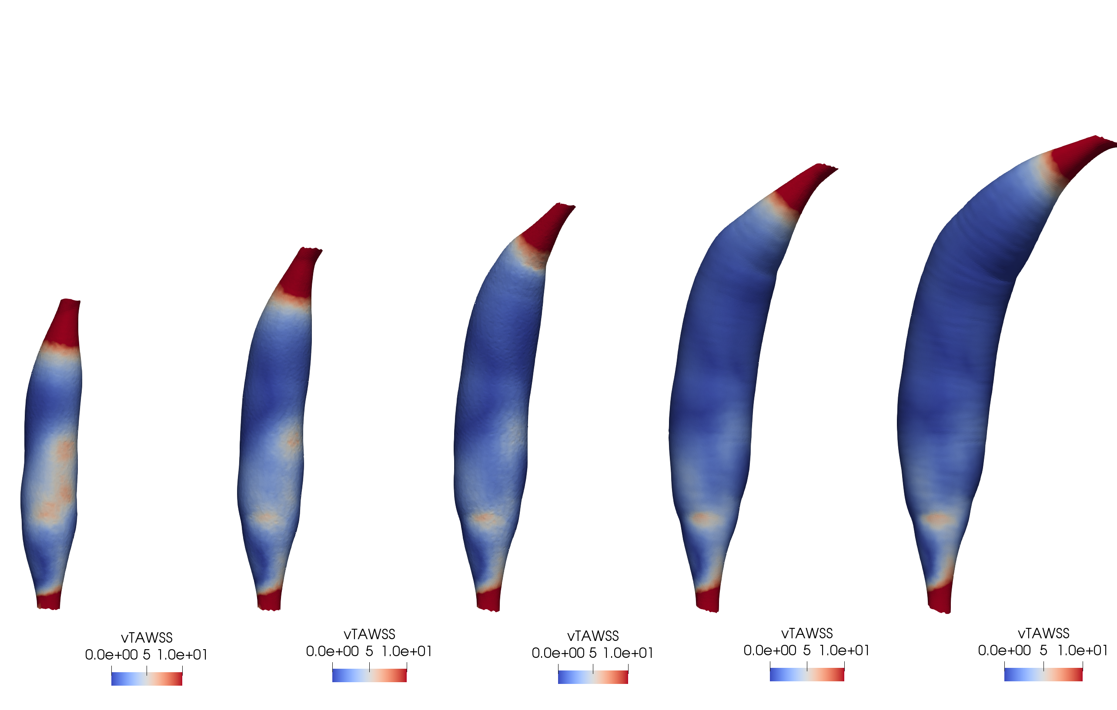

## Hemodynamic variations with aneurysm shape and size

Surface hemodynamic patterns appear to vary consistently with respect to increasing Z-score. Qualitatively, we observe that the aneurysmal region, with increased diameter relative to uninvolved vessel regions, features generally lower TAWSS values (Figure ___). Additionally, for each value of ASI, aneurysms appear to bear similar spatial distributions of TAWSS as Z-score increases. The expectation is that increase in diameter decreases flow rate, a phenomenon reflected in the distribution of wall shear stress over the aneurysmal surface.

In addition to qualitative observations, we can quantify aneurysm hemodynamics through aggregate hemodynamic parameters, demonstrating that multiple combinations of aneurysm shape and size and produce similar hemodynamics. This is best exemplified in Figure ___, in which we can see that multiple combinations of shape index and Z-score produce highly similar values of surface-averaged TAWSS.

In addition, we can examine the fraction of aneurysm wall surface exposed to critical thresholds of TAWSS as another measure of internal fluid behavior. We expect the fractional area exposed to a low threshold of TAWSS to correspond to regions of recirculation within the aneurysm. Indeed, we observe correlations between fractional surface area and both ASI and Z-score (Figure ___). As with surface-averaged TAWSS, the fractional area plots suggest that multiple combinations of ASI and Z-score contribute to similar hemodynamic behavior.

Overall, aggregate hemodynamic values are consistently stratified by aneurysm Z-score and display non-linear variation with respect to aneurysm shape index.

## Positional effects on aneurysm hemodynamics

CAAs secondary to KD often present in multiple regions along the RCA and LAD. Aneurysms were evaluated in proximal, medial, and distal positions along the RCA, re

It is thus important to investigate which factors, such as flow rate and vessel curvature, underlie positional variation in aneurysmal hemodynamics.

## Volume effects on aneurysm hemodynamics

Although both Aneurysm Shape Index, the ratio between aneurysm length and diameter, and Z-score, a measure of aneurysm diameter, are effective measures for aneurysmal shape, both may be related through aneurysmal volume. Intuitively, total aneurysm volume may be an effective proxy for understanding the extent of fluid recirculation and stagnation.

Residence Time varies consistently with respect to aneurysm size and shape, demonstrating strong correlation with aneurysm volume. Residence Time grows predictably as idealized aneurysms change in length and diameter. Intuitively, Residence Time measures the time that massless particles spend within the aneurysm. Despite normalization with respect to aneurysm volume, RT1 still shows strong association with aneurysm volume in a pooled analysis of all aneurysms regardless of location, diameter, and shape (**Figure ???**).

## Curvature effects on aneurysm hemodynamics

The curvature of the coronary vessels may be responsible for the angle of the inflow jet and aneurysm hemodynamics. Qualitatively, we observe that the curvature of the aneurysm is responsible for the impingement of the inflow jet against the vessel wall, influencing distributions of hemodynamic parameters such as TAWSS.

Idealized aneurysm models suggest that aggregates of quantities of interest, such as the average TAWSS over the aneurysm surface, mirror the largest components of aneurysm shape variability but potentially fail to elucidate smaller-scale hemodynamic variations. Idealized aneurysm models show consistent variation in distribution of hemodynamic parameters as Z- score increases, as seen in **Figure ???**. TAWSS distribution varies consistently with ASI while holding Z-score constant. As in **Figure ???**, percentage of area exposed to low TAWSS increases with ASI at all Z- scones. Similar trends are observed in aneurysm cases in the LAD.

Clinical Predictive Value

# Discussion

The importance of accurate risk stratification methods for patients with coronary artery aneurysms secondary to Kawasaki Disease is well understood. Indeed, studies over the last several years have shown the AHA’s diameter-based algorithm for initiation of systemic anticoagulation to be insufficient for effectively predicting patient risk. Although these studies have explored the potential for patient-specific simulations to reveal key hemodynamic predictors underlying thrombotic risk, the variability of these predictors with respect to patient anatomy and aneurysm geometry has remained unclear.

Through the idealized aneurysm models, Z-score remains a strong predictor of hemodynamic behavior. Within **Figures [aoirjaow]**, we can still see the role of diameter as consistent trends in average TAWSS and RT1 with respect aneurysm Z-score at each level of ASI.

It has also been shown that TAWSS over aneurysmal regions is associated with risk of thrombosis, and that a decision boundary based on percentage of aneurysm surface area exposed to low TAWSS is more predictive of thrombosis than aneurysm diameter for KD patients. Thus, we assess the distribution of TAWSS over the surface as one potential surrogate for hemodynamic behaviors that may underlie thrombosis. Results exemplified by **Figure ????** show that aneurysm diameter alone may not be sufficient to predict local hemodynamic variables such as TAWSS. Aneurysms similar in diameter but with different aspect ratios can furnish substantially different hemodynamic environments. In some cases, smaller diameter aneurysms with higher ASI (fusiform shape) even produce lower TAWSS values than more saccular aneurysms with larger maximum diameter. A combination of aneurysm shape and length, in addition to other potential factors such as vessel curvature and aneurysm position, may thus be the primary factors determining local hemodynamic behaviors.

Although we have systematically investigated the role of shape parameters on aggregate measures of aneurysm hemodynamics, further work should continue to investigate the potential for low-dimensional representations of aneurysm shape towards improving clinical predictive value. Known correlations between aneurysm hemodynamic and geometric features suggest potential to link clinical measurements easily obtained from echocardiography or other routine imaging modality, with patient outcome. Such approaches may form the basis for more sophisticated geometry-based risk stratification methods supporting clinical decision- making in assessment of KD patients.

# Acknowledgements

# References